20 One Grateful: Getting Started

*You have to have a gmail account. If you don’t have one already, set one up. Don’t worry, your gmail account name won’t be visible as part of your blog. Send yourself an email to keep your password handy. You will need it to log on at www.blogger.com

Rules of the Blog
Remember, this blog is for a school assignment.
1. Keep it safe
2. Keep it anonymous to the public (see below about controlling permissions)
3. Keep it “G-Rated”

Set Up Your Blog
*If you already have a blog with Blogger.com, create a new blog for this project.
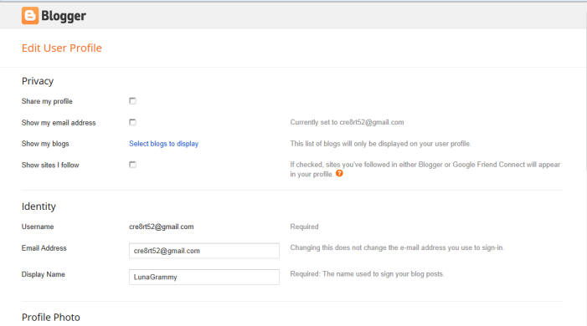
1. First, edit your user profile so that your email name isn’t displayed:
Uncheck all boxes
Enter your user name
Enter your gmail address
Enter your DISPLAY NAME (this is the name that will show on your blog, so keep it anonymous and g-rated)
DO NOT complete any other information on the profile page except ‘Country’. Choose United States.

Choices for Your Blog
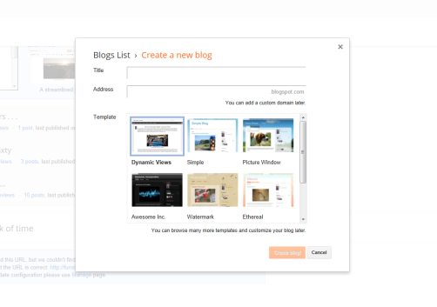
Any title, but it should reflect your purpose.

You may have to try MANY url addresses for one that’s not already taken . . .
Write down ALL of your information: gmail account, password, blogger user name, blog name, AND url, then email it to yourself and keep the email! Turn in the Blog document with all information except gmail and passwords.
Any template. You can make changes any time.

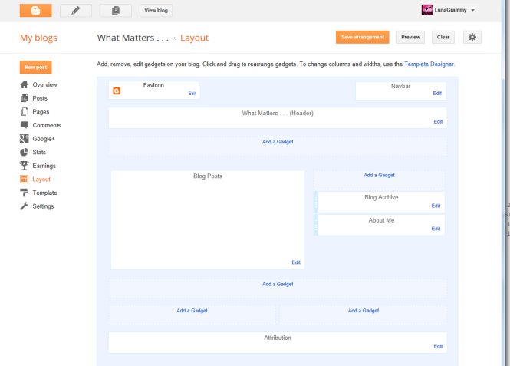
You can start designing your blog. Make it as simple or complex as you choose.
For example, choose fonts, add gadgets
(a counter is fun: add Blog’s Stats)
You can write in the “About Me” as long as you don’t write anything that can identify you specifically. Get this checked by me BEFORE YOU POST!

Check Your Settings
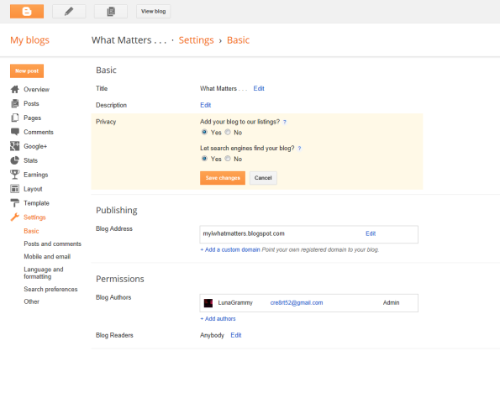
Go to the menu bar on the left to edit your settings. You can select ‘NO’ if you wish to limit your privacy and make your blog non public. (If you do this, you will have to add all other students to your ‘readers list’.)

You’re almost ready to start your 20 One Grateful project!

Check out my blog, What Matters . . . , for more information!

